PROJECT TITLE: Student Report Card System

NAME: S.Bhathmanapan

REG NO: RA2111002010117

DEPARTMENT : Mech-A

SUBMITTED TO

DR. R. RAJKUMAR

DSBS

SCHOOL OF COMPUTING

SRMIST

JANUARY 2022

ABSRACT :

The mini-project “Student Record System Project in C” is a console application using the C programming language. This project compiled in Code Blocks with the GCC compiler. In this console application, you can do basic Student Record tasks like adding the student info, view the added student, search the students, ..etc.This application based on[**file handling in C**](https://aticleworld.com/file-handling-in-c/), where I have used a file-related function like **[fopen](https://aticleworld.com/fopen-in-c/" \t "_blank)**, **[fread](https://aticleworld.com/fread-in-c/" \t "_blank)**, **[fwrite](https://aticleworld.com/fwrite-in-c/" \t "_blank)**, ..etc. Good thing is that “Student Record System Project” is password-protected, so only authorized persons able to login to this application.Also to increase the readability, I have broken the application in different functions. Each function of the project extensively use in the [**file handing function**](https://aticleworld.com/file-handling-in-c/), so it is also a great project to do.

**The appearance of your student records says a lot about the quality of your school.Other educators and registrars make judgments based on student records that canpermanently affect a student's life. SMS capabilities include the basics such astranscripts , report cards, attendance, and discipline as well as many other specializedcapabilities , including parental access to real time student grades on theInternet. This means that not only administrators but also parents, teachers, andstudents have access to real-time data. With traditional reporting methods parentsmay not find out how their student is performing in school until the end of the quarteror semester -- usually too late to correct a problem situation. SMS allows parents toknow how their student is doing on a continual basis by using the internet. SMS can even send electronic progress reports to parents via email on a weekly, monthly, oreven daily basis.**

FLOW CHART

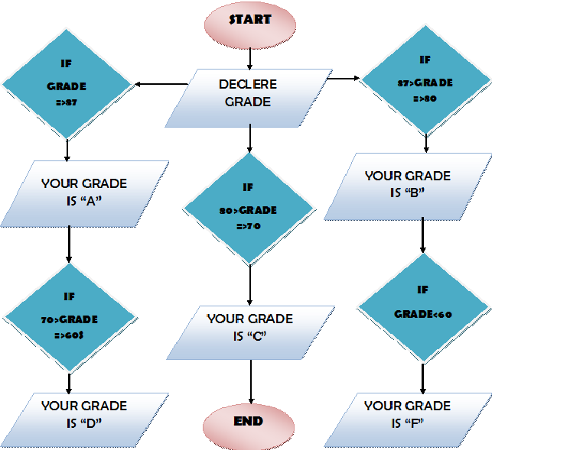

PROGRAM

|  |
| --- |
| #include<conio.h> |
|  |  | #include<stdio.h> |
|  |  | #include<process.h> |
|  |  | struct student |
|  |  | { |
|  |  | int rollno; |
|  |  | char name[50]; |
|  |  | int p\_marks,c\_marks,m\_marks,e\_marks,cs\_marks; |
|  |  | float per; |
|  |  | char grade; |
|  |  | int std; |
|  |  | }st; |
|  |  | FILE \*fptr; |
|  |  | void write\_student() |
|  |  | { |
|  |  | fptr=fopen("student.dat","ab"); |
|  |  | printf("\nPlease Enter The New Details of student \n"); |
|  |  | printf("\nEnter The roll number of student "); |
|  |  | scanf("%d",&st.rollno); |
|  |  | fflush(stdin); |
|  |  | printf("\n\nEnter The Name of student "); |
|  |  | gets(st.name); |
|  |  | printf("\nEnter The marks in physics out of 100 : "); |
|  |  | scanf("%d",&st.p\_marks); |
|  |  | printf("\nEnter The marks in chemistry out of 100 : "); |
|  |  | scanf("%d",&st.c\_marks); |
|  |  | printf("\nEnter The marks in maths out of 100 : "); |
|  |  | scanf("%d",&st.m\_marks); |
|  |  | printf("\nEnter The marks in english out of 100 : "); |
|  |  | scanf("%d",&st.e\_marks); |
|  |  | printf("\nEnter The marks in computer science out of 100 : "); |
|  |  | scanf("%d",&st.cs\_marks); |
|  |  | st.per=(st.p\_marks+st.c\_marks+st.m\_marks+st.e\_marks+st.cs\_marks)/5.0; |
|  |  | if(st.per>=60) |
|  |  | st.grade='A'; |
|  |  | else if(st.per>=50 &&st.per<60) |
|  |  | st.grade='B'; |
|  |  | else if(st.per>=33 &&st.per<50) |
|  |  | st.grade='C'; |
|  |  | else |
|  |  | st.grade='F'; |
|  |  | fwrite(&st,sizeof(st),1,fptr); |
|  |  | fclose(fptr); |
|  |  | printf("\n\nStudent Record Has Been Created "); |
|  |  | getch(); |
|  |  | } |
|  |  |  |
|  |  |  |
|  |  |  |
|  |  | void display\_all() |
|  |  | { |
|  |  | clrscr(); |
|  |  | printf("\n\n\n\t\tDISPLAY ALL RECORD !!!\n\n"); |
|  |  | fptr=fopen("student.dat","rb"); |
|  |  | while((fread(&st,sizeof(st),1,fptr))>0) |
|  |  | { |
|  |  | printf("\nRoll Number of Student : %d",st.rollno); |
|  |  | printf("\nName of student : %s",st.name); |
|  |  | printf("\nMarks in Physics : %d",st.p\_marks); |
|  |  | printf("\nMarks in Chemistry : %d",st.c\_marks); |
|  |  | printf("\nMarks in Maths : %d",st.m\_marks); |
|  |  | printf("\nMarks in English : %d",st.e\_marks); |
|  |  | printf("\nMarks in Computer Science : %d",st.cs\_marks); |
|  |  | printf("\nPercentage of student is : %.2f",st.per); |
|  |  | printf("\nGrade of student is : %c",st.grade); |
|  |  | printf("\n\n====================================\n"); |
|  |  | getch(); |
|  |  | } |
|  |  | fclose(fptr); |
|  |  | getch(); |
|  |  | } |
|  |  |  |
|  |  |  |
|  |  |  |
|  |  | void display\_sp(int n) |
|  |  | { |
|  |  | int flag=0; |
|  |  | fptr=fopen("student.dat","rb"); |
|  |  | while((fread(&st,sizeof(st),1,fptr))>0) |
|  |  | { |
|  |  | if(st.rollno==n) |
|  |  | { |
|  |  | clrscr(); |
|  |  | printf("\nRoll number of student : %d",st.rollno); |
|  |  | printf("\nName of student : %s",st.name); |
|  |  | printf("\nMarks in Physics : %d",st.p\_marks); |
|  |  | printf("\nMarks in Chemistry : %d",st.c\_marks); |
|  |  | printf("\nMarks in Maths : %d",st.m\_marks); |
|  |  | printf("\nMarks in English : %d",st.e\_marks); |
|  |  | printf("\nMarks in Computer Science : %d",st.cs\_marks); |
|  |  | printf("\nPercentage of student is : %.2f",st.per); |
|  |  | printf("\nGrade of student is : %c",st.grade); |
|  |  | flag=1; |
|  |  | } |
|  |  | } |
|  |  | fclose(fptr); |
|  |  | if(flag==0) |
|  |  | printf("\n\nrecord not exist"); |
|  |  | getch(); |
|  |  | } |
|  |  |  |
|  |  |  |
|  |  |  |
|  |  | void modify\_student() |
|  |  | { |
|  |  | int no,found=0; |
|  |  | clrscr(); |
|  |  | printf("\n\n\tTo Modify "); |
|  |  | printf("\n\n\tPlease Enter The roll number of student"); |
|  |  | scanf("%d",&no); |
|  |  | fptr=fopen("student.dat","rb+"); |
|  |  | while((fread(&st,sizeof(st),1,fptr))>0 && found==0) |
|  |  | { |
|  |  | if(st.rollno==no) |
|  |  | { |
|  |  | printf("\nRoll number of student : %d",st.rollno); |
|  |  | printf("\nName of student : %s",st.name); |
|  |  | printf("\nMarks in Physics : %d",st.p\_marks); |
|  |  | printf("\nMarks in Chemistry : %d",st.c\_marks); |
|  |  | printf("\nMarks in Maths : %d",st.m\_marks); |
|  |  | printf("\nMarks in English : %d",st.e\_marks); |
|  |  | printf("\nMarks in Computer Science : %d",st.cs\_marks); |
|  |  | printf("\nPercentage of student is : %.2f",st.per); |
|  |  | printf("\nGrade of student is : %c",st.grade); |
|  |  | printf("\nPlease Enter The New Details of student \n"); |
|  |  | printf("\nEnter The roll number of student "); |
|  |  | scanf("%d",&st.rollno); |
|  |  | fflush(stdin); |
|  |  | printf("\n\nEnter The Name of student "); |
|  |  | gets(st.name); |
|  |  | printf("\nEnter The marks in physics out of 100 : "); |
|  |  | scanf("%d",&st.p\_marks); |
|  |  | printf("\nEnter The marks in chemistry out of 100 : "); |
|  |  | scanf("%d",&st.c\_marks); |
|  |  | printf("\nEnter The marks in maths out of 100 : "); |
|  |  | scanf("%d",&st.m\_marks); |
|  |  | printf("\nEnter The marks in english out of 100 : "); |
|  |  | scanf("%d",&st.e\_marks); |
|  |  | printf("\nEnter The marks in computer science out of 100 : "); |
|  |  | scanf("%d",&st.cs\_marks); |
|  |  | st.per=(st.p\_marks+st.c\_marks+st.m\_marks+st.e\_marks+st.cs\_marks)/5.0; |
|  |  | if(st.per>=60) |
|  |  | st.grade='A'; |
|  |  | else if(st.per>=50 && st.per<60) |
|  |  | st.grade='B'; |
|  |  | else if(st.per>=33 && st.per<50) |
|  |  | st.grade='C'; |
|  |  | Else |
|  |  | st.grade='F'; |
|  |  | fseek(fptr,-(long)sizeof(st),1); |
|  |  | fwrite(&st,sizeof(st),1,fptr); |
|  |  | printf("\n\n\t Record Updated"); |
|  |  | found=1; |
|  |  | } |
|  |  | } |
|  |  | fclose(fptr); |
|  |  | if(found==0) |
|  |  | printf("\n\n Record Not Found "); |
|  |  | getch(); |
|  |  | } |
|  |  |  |
|  |  |  |
|  |  |  |
|  |  |  |
|  |  |  |
|  |  | void delete\_student() |
|  |  | { |
|  |  | int no; |
|  |  | FILE \*fptr2; |
|  |  | clrscr(); |
|  |  | printf("\n\n\n\tDelete Record"); |
|  |  | printf("\n\nPlease Enter The roll number of student You Want To Delete"); |
|  |  | scanf("%d",&no); |
|  |  | fptr=fopen("student.dat","rb"); |
|  |  |  |
|  |  | fptr2=fopen("Temp.dat","wb"); |
|  |  | rewind(fptr); |
|  |  | while((fread(&st,sizeof(st),1,fptr))>0) |
|  |  | { |
|  |  | if(st.rollno!=no) |
|  |  | { |
|  |  | fwrite(&st,sizeof(st),1,fptr2); |
|  |  | } |
|  |  | } |
|  |  | fclose(fptr2); |
|  |  | fclose(fptr); |
|  |  | remove("student.dat"); |
|  |  | rename("Temp.dat","student.dat"); |
|  |  | printf("\n\n\tRecord Deleted .."); |
|  |  | getch(); |
|  |  | } |
|  |  |  |
|  |  |  |
|  |  |  |
|  |  | void class\_result() |
|  |  | { |
|  |  | clrscr(); |
|  |  | fptr=fopen("student.dat","rb"); |
|  |  | if(fptr==NULL) |
|  |  | { |
|  |  | printf("ERROR!!! FILE COULD NOT BE OPEN\n\n\n Go To Entry Menu to create File"); |
|  |  | printf("\n\n\n Program is closing ...."); |
|  |  | getch(); |
|  |  | exit(0); |
|  |  | } |
|  |  |  |
|  |  | printf("\n\n\t\tALL STUDENTS RESULT \n\n"); |
|  |  | printf("====================================================\n"); |
|  |  | printf("R.No. Name P C M E CS %age Grade\n"); |
|  |  | printf("====================================================\n"); |
|  |  |  |
|  |  | while((fread(&st,sizeof(st),1,fptr))>0) |
|  |  | { |
|  |  | printf("%-6d %-10s %-3d %-3d %-3d %-3d %-3d %-3.2f %-1c\n",st.rollno,st.name,st.p\_marks,st.c\_marks,st.m\_marks,st.e\_marks,st.cs\_marks,st.per,st.grade); |
|  |  | } |
|  |  | fclose(fptr); |
|  |  | getch(); |
|  |  | } |
|  |  |  |
|  |  |  |
|  |  |  |
|  |  | void result() |
|  |  | { |
|  |  | int ans,rno; |
|  |  | char ch; |
|  |  | clrscr(); |
|  |  | printf("\n\n\nRESULT MENU"); |
|  |  | printf("\n\n\n1. Class Result\n\n2. Student Report Card\n\n3.Back to Main Menu"); |
|  |  | printf("\n\n\nEnter Choice (1/2)? "); |
|  |  | scanf("%d",&ans); |
|  |  | switch(ans) |
|  |  | { |
|  |  | case 1 : class\_result();break; |
|  |  | case 2 : { |
|  |  | do{ |
|  |  | char ans; |
|  |  | clrscr(); |
|  |  | printf("\n\nEnter Roll Number Of Student : "); |
|  |  | scanf("%d",&rno); |
|  |  | display\_sp(rno); |
|  |  | printf("\n\nDo you want to See More Result (y/n)?"); |
|  |  | scanf("%c",&ans); |
|  |  | }while(ans=='y'||ans=='Y'); |
|  |  | break; |
|  |  | } |
|  |  | case 3: break; |
|  |  | default: printf("\a"); |
|  |  | } |
|  |  | } |
|  |  |  |
|  |  |  |
|  |  | void intro() |
|  |  | { |
|  |  | clrscr(); |
|  |  | gotoxy(35,11); |
|  |  | printf("STUDENT"); |
|  |  | gotoxy(33,14); |
|  |  | printf("REPORT CARD"); |
|  |  | gotoxy(35,17); |
|  |  | printf("PROJECT"); |
|  |  | printf("\n\n\n\n\n\nMADE BY : SULABH AGRAWAL"); |
|  |  | printf("\n\nCOLLEGE : ASN ENGINEERING COLLEGE"); |
|  |  | getch(); |
|  |  | } |
|  |  |  |
|  |  | void entry\_menu() |
|  |  | { |
|  |  | char ch2; |
|  |  | clrscr(); |
|  |  | printf("\n\n\n\tENTRY MENU"); |
|  |  | printf("\n\n\t1.CREATE STUDENT RECORD"); |
|  |  | printf("\n\n\t2.DISPLAY ALL STUDENTS RECORDS"); |
|  |  | printf("\n\n\t3.SEARCH STUDENT RECORD "); |
|  |  | printf("\n\n\t4.MODIFY STUDENT RECORD"); |
|  |  | printf("\n\n\t5.DELETE STUDENT RECORD"); |
|  |  | printf("\n\n\t6.BACK TO MAIN MENU"); |
|  |  | printf("\n\n\tPlease Enter Your Choice (1-6) "); |
|  |  | ch2=getche(); |
|  |  | switch(ch2) |
|  |  | { |
|  |  | case '1': clrscr(); |
|  |  | write\_student(); |
|  |  | break; |
|  |  | case '2': display\_all();break; |
|  |  | case '3': { |
|  |  | int num; |
|  |  | clrscr(); |
|  |  | printf("\n\n\tPlease Enter The roll number "); |
|  |  | scanf("%d",&num); |
|  |  | display\_sp(num); |
|  |  | } |
|  |  | break; |
|  |  | case '4': modify\_student();break; |
|  |  | case '5': delete\_student();break; |
|  |  | case '6': break; |
|  |  | default:printf("\a");entry\_menu(); |
|  |  | } |
|  |  | } |
|  |  | void main() |
|  |  | { |
|  |  | char ch; |
|  |  | intro(); |
|  |  | Do |
|  |  | { |
|  |  | clrscr(); |
|  |  | printf("\n\n\n\tMAIN MENU"); |
|  |  | printf("\n\n\t01. RESULT MENU"); |
|  |  | printf("\n\n\t02. ENTRY/EDIT MENU"); |
|  |  | printf("\n\n\t03. EXIT"); |
|  |  | printf("\n\n\tPlease Select Your Option (1-3) "); |
|  |  | ch=getche(); |
|  |  | switch(ch) |
|  |  | { |
|  |  | case '1': clrscr(); |
|  |  | result(); |
|  |  | break; |
|  |  | case '2': entry\_menu(); |
|  |  | break; |
|  |  | case '3':exit(0); |
|  |  | default :printf("\a"); |
|  |  | } |
|  |  | }while(ch!='3'); |
|  |  | } |

RESULTS :

The Given Program is verified as “The Student Report card System”

SCREENSHOTS

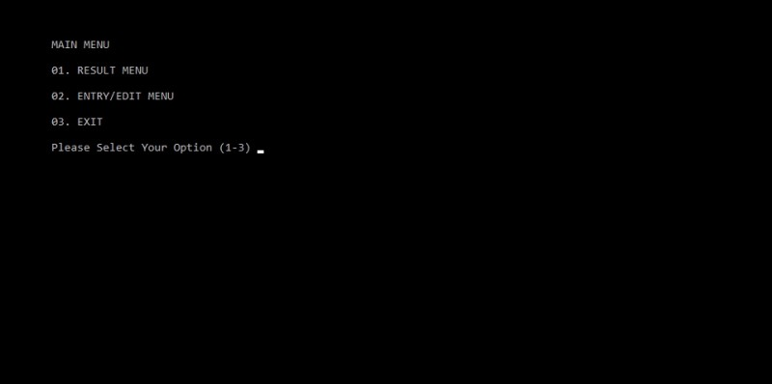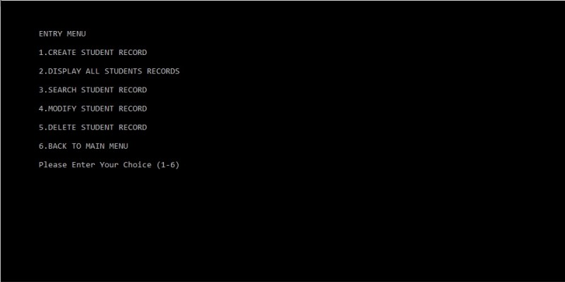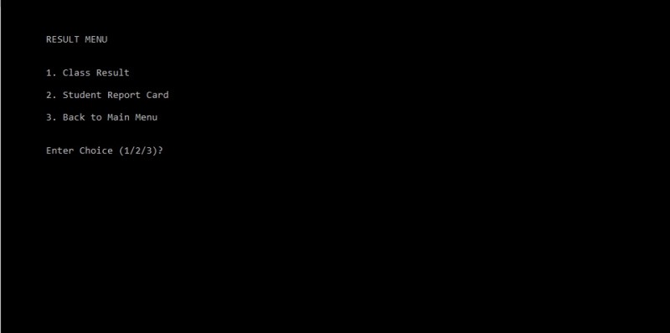

DECLARATION :

Thus the project is verified.thanks to all..

RERERENCES :

For more quries search https://github.com/yasirwahid/C-C-projects/commit/8da13b5ef77cfbad5385b49d9c3c2193b27418d5.